<https://youtu.be/ioxZxqBF7TU?si=4qaH3BSZN-cpZ_-Y>

How codes become themes

<https://youtu.be/mrioduYXWE4?si=OfSCEqyhuF8O3STe>

Nvivo for beginners 1 (Philip Adu)

<https://youtu.be/1erIajGquxg?si=RzYwvkFsWzQvCSyI>

Going from codes to themes

<https://youtu.be/L9TpNG-V2Uc?si=Vq3ePbUyxoByZD6m>

Deriving themes from qualitative data

<https://youtu.be/fI-kSSHjWxM?si=eEdM7xc5BMFiq_Cz>.

Nvivo for beginners 2 (Philip Adu)

<https://youtu.be/pGmGBks8W9Y?si=utJw8uqA0XqoRoyV>

Understanding data through Nvivo

<https://youtu.be/mrioduYXWE4?si=413znrutDvi-iImW>

Categorise Codes

<https://youtu.be/YefISJUAFks?si=GPWpu1eGmhAXHKb5>

Visualizing your result

**Nvivo for Beginners**

* **Coding:** Going through the data identifying something (**information**) that is significant. The process:
  + Go through your transcript
  + Identify significant information
  + Create your containers
  + Files: No. of participants that said sth. relating to the significant information.
  + Reference: No. of significant information
* **Dominant code:** Code with the highest number of wordcount.
* Make sure your questionnaire designed is addressing the Research Questions.
* Cleaning your Data is important to getting it ready for analysis.
* If you are NOT planning to specifically do some comparison or study of some demographic information (Quantitative), you might not need to send them to Nvivo.
* Nvivo: Containers and Coding.
* Know the type of Analysis you are doing:
  + Thematic Analysis: Generating codes and themes **during** the process of coding the data.
  + Content Analysis: Generating codes and themes **before** coding the data.

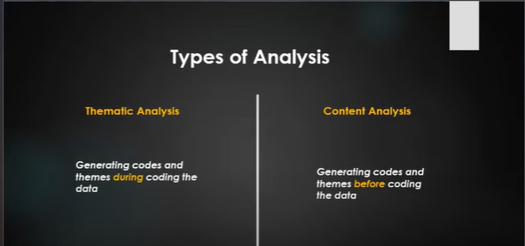

* **Coding Strategies (**How codes are generated)

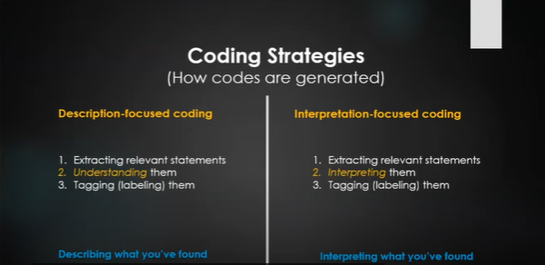

* **Next is**, Bracketing (reflecting on your past experiences; preconceived ideas)
* **PS:** 1)At the end of the day, you don’t have to code everything that you see in your data. You are coding things that are going to help you address your research questions. 2) Coding is NOT to address interview questions, you ARE coding to address your interview questions.
* **PS:** 1) Interview Questions: help you collect data from participants. 2) Research Questions: the one you have to use the interview responses to address. But not using the interview responses to address the interview questions.
* **Big Picture:** You are addressing the Research Questions, not the Interview Questions.

**Next: 1) Categorise the codes; 2) Understanding data through Nvivo**